# Article Outcomes:

700-1000 words

7th grade reading level

SEO Optimized article that soft sells my product

Paragraphs cannot excede 100 words

Max 250 words between subheadlines

Sentences should be 20 words or less. Occasionally go up to 25 words less than 10% of the time

# Article Format

Headliine - 50-65 characters

Intro paragraph - uses keyphrase in the first sentence. 50-100 words

Subheadline

2-3 paragraphs

Call to action to book a meeting with our team

Subheadline

2-3 paragraphs

Call to action to get a quote from our team

Subheading

Closing 1-2 paragraphs

# Topic:

Multi-Platform RPA Management

Key ideas to include:

* Traditionally automation companies have tried to lock you into using just their tech stack. As technology evolves ever faster the ability to use third party tools is more important.
* Some customers have built many automations on one platform but want to use the new tools of another.
* It used to be to change platforms you had to recode all of your automations
* Now you can keep the old automations running and innovate on a new platform or new tools and coordinate the hand off of tasks from one system to the other with a Universal Orchestrator.
* Multi-platform orchestration is cheaper than migrating your entire code base and more flexible.
* Allows you to take advantage of mixing in low cost alternatives with your top self RPA tools.

# Products to include

Universal orchestrator to manage multiple RPA platforms like Blue Prism, UiPath, Automation anywhere.

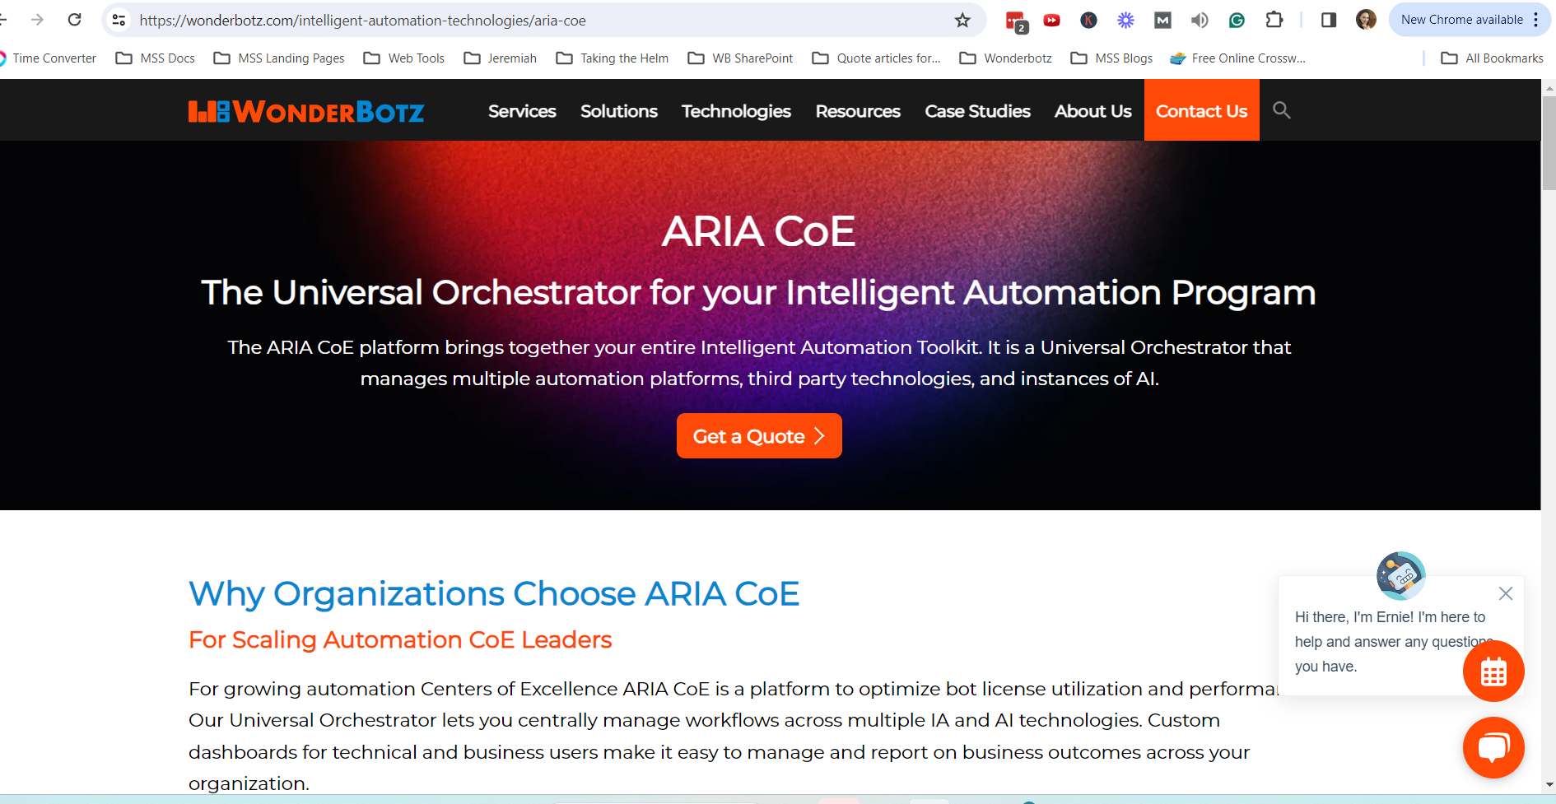

<https://wonderbotz.com/intelligent-automation-technologies/aria-coe>

Product page to reference

Mention and soft sell this product as the solution to Multi-platform RPA management

<https://wonderbotz.com/intelligent-automation-technologies/aria-cloud/>

# Example of other article for style and company voice

<https://wonderbotz.com/articles/rpa-cloud-migration-why-secure-cloud-is-the-critical-path-to-ai-readiness/>

<https://wonderbotz.com/articles/exciting-new-uses-for-chatgpt-and-ai-in-automation-technology/>

# SEO Glidelines

Primary Key phrase:

Multiplatform RPA Orchestration

For SEO the Key phrase must be used in:

* The title
* 1 subheadline
* 3 times in the body text
* In the meta title
* In the meta description